**NEPAL COLLEGE OF INFORMATION TECHNOLOGY**

**Balkumari, Lalitpur**



**A Lab Report**

**On**

**Subject:- Web Technology**

**Lab Report # _6__.**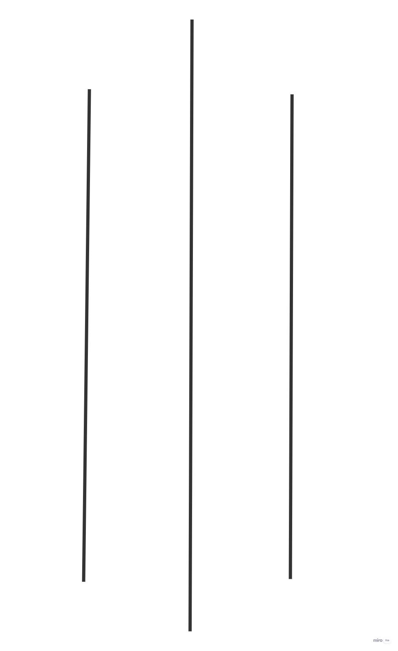

**Title: - - Introduction to CSS, Types of CSS and All kinds of Selectors present in CSS. Different kinds of Style with their properties.**

**Submitted by:- Submitted to:-**

**Name : - Abiral Chaudhary Instructor: - Simanta Kasaju**

**Roll No:- 221702 Department :- software**

**Faculty: - science and technology Submission Date:2080/03/28**

**Semester:-II**

**OBJECTIVE:**

Familiarization with all kinds of Selectors and different kinds of Style with their properties present in CSS.

**THEORY:**

**Introduction:**

CSS stands for “Cascading Style Sheets”. CSS is a widely used language on the web.HTML, CSS and JavaScript are used for web designing. It helps the web designers to apply style on HTML tags.

➢ **Cascading:** refers to the procedure that determine which style will apply to a certain section, if you have more than one style rule.

➢ **Style:** how you want a certain part of your page to look. You can set things like color, margins, font etc for things like tables, paragraphs and headings.

➢ **Sheets:** the “sheets” are like templates, or a set of rules, for determine how the web page will look. So, CSS (all together) is a styling language-is set of rules to tell browsers how your webpage should look.

• **Why to Use CSS?**

CSS is used to define styles for your web pages, including the design, layout and variations in display for different devices and screen sizes.

**CSS Syntax**

• A CSS rule set contains a selector and a declaration block.

Selector: Selector indicates the HTML element you want to style. It could be

any tag like <h1>, <title> etc.

• Declaration Block: The declaration block can contain one or more

declarations separated by a semicolon. For the above example, there are two

declarations:

1.color: blue;

2.font-size: 12 px;

• Each declaration contains a property name and value, separated by a colon.

• Property: A Property is a type of attribute of HTML element. It could be color,

border etc.

• Value: Values are assigned to CSS properties. In the above example, value

“blue" is assigned to color property.

**• Types of CSS (Linking style of CSS with HTML)**

**1. Inline CSS:**

Inline CSS is used to style a specific HTML element. Add a style attribute to each HTML tag without using the selectors. Managing a website may difficult if we use only inline CSS. However, Inline CSS in HTML is useful in some situations. We have not accessed the CSS files or to apply styles to element. An Inline style loses many of the advantages of style sheet. To use inline styles, add the style attribute to the relevant tag. The style attribute can contain any CSS property. In the following example, we have used the inline CSS in <p> and <h1> tag.

**2. Internal CSS (Embedded Style):**

The Internal CSS has <style> tag in the <head> section of the HTML document. This CSS style is an effective way to style single pages. Using the CSS style for multiple web pages are time-consuming because we require placing the style on each web page. We can use the internal CSS by using the following steps:

i. Firstly, open the HTML page and locate the <head>

ii. Put the following code after the <head>

iii. Add the rules of CSS in the new line.

iv. Close the style tag.

**3. External CSS**

In external CSS, we link the web pages to the external .css file. It is created by text editor. The CSS is more efficient method for styling a website. By editing the .css file, we can change the whole site at once. To use the external CSS, follow the steps, given below:

•An external style sheet can be written in any text editor.

• Your style sheet should be saved with a .css extension.

Eg hr{ color : blue; } p{ margin-left : 20px; } body{ background-image

url(“images/back40.gif”); }

**• CSS simple basic selectors**

**1. The CSS element Selector**

The element selector selects HTML elements based on the element name.

Example:Here, all <p> elements on the page will be center-aligned, with a red text color:

p {

text-align: center;

color: red;

}

**2. The CSS id Selector**

The id selector uses the id attribute of an HTML element to select a specific element.

The id of an element is unique within a page, so the id selector is used to select one

unique element! To select an element with a specific id, write a hash (#) character,

followed by the id of the element.

#para1 {

text-align: center;

color: red;

}

**3. The CSS class Selector**

The class selector selects HTML elements with a specific class attribute. To select

elements with a specific class, write a period (.) character, followed by the class name.

.center{

text-align: center;

color: red;

}

You can also specify that only specific HTML elements should be affected by a class.

p.center{

text-align: center;

color: red;

}

**4. The CSS Universal Selector**

The universal selector (*) selects all HTML elements on the page.

* {

text-align: center;

color: blue;

}

**5. The CSS Grouping Selector**

The grouping selector selects all the HTML elements with the same style definitions.Look at the following CSS code (the h1, h2, and p elements have the same style definitions):

h1 {

text-align: center;

color: red;

}

h2 {

text-align: center;

color: red;

}

p {

text-align: center;

color: red;

}

are equivalent to:

h1, h2, p {

text-align: center;

color: red;

}

**Question 1):** Write an HTML & CSS code to demonstrate the usage of inline, Internal & External CSS.

**Code:**

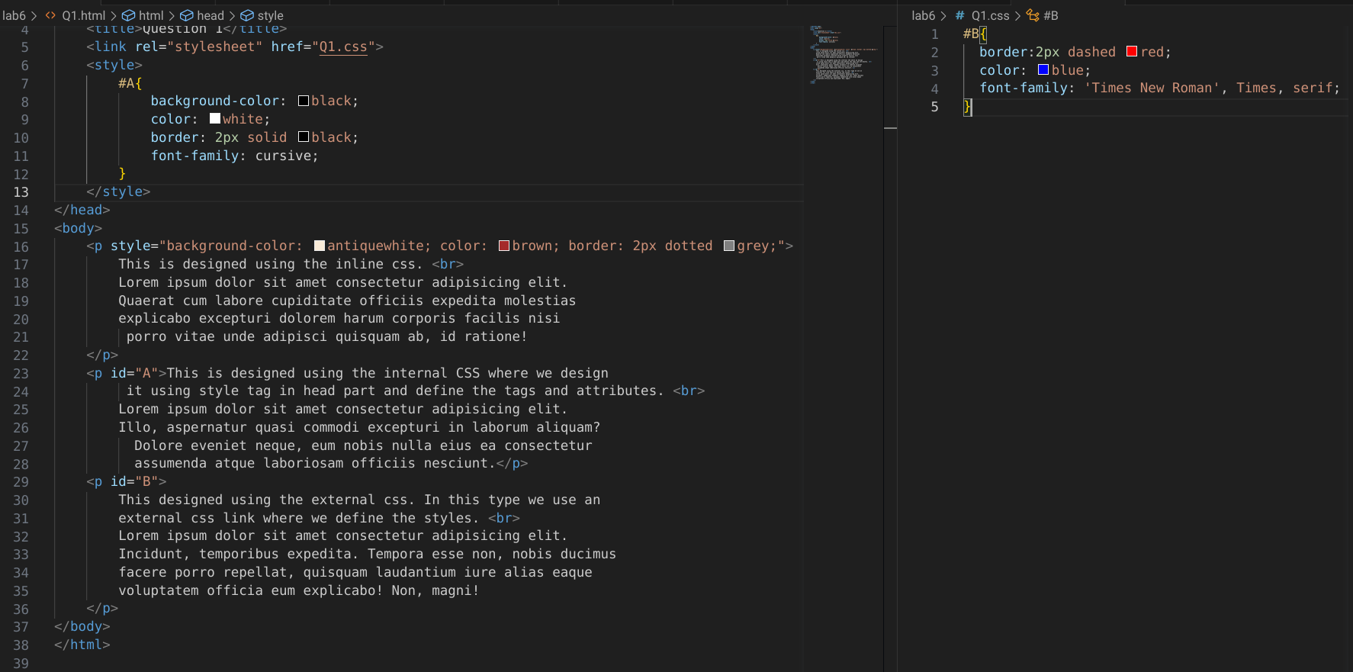

**Output:**

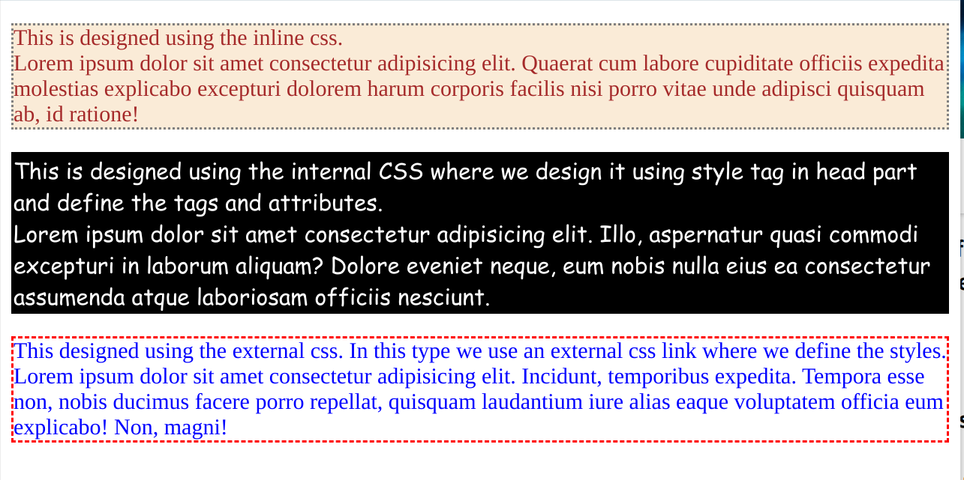

**Question 2): Write a program to Use different font, styles: In the style definition you define how each selector should work (font, color etc.). Then in the body of your pages, you refer to these selectors to activate the styles. (All selector must be done)**

**Code:**

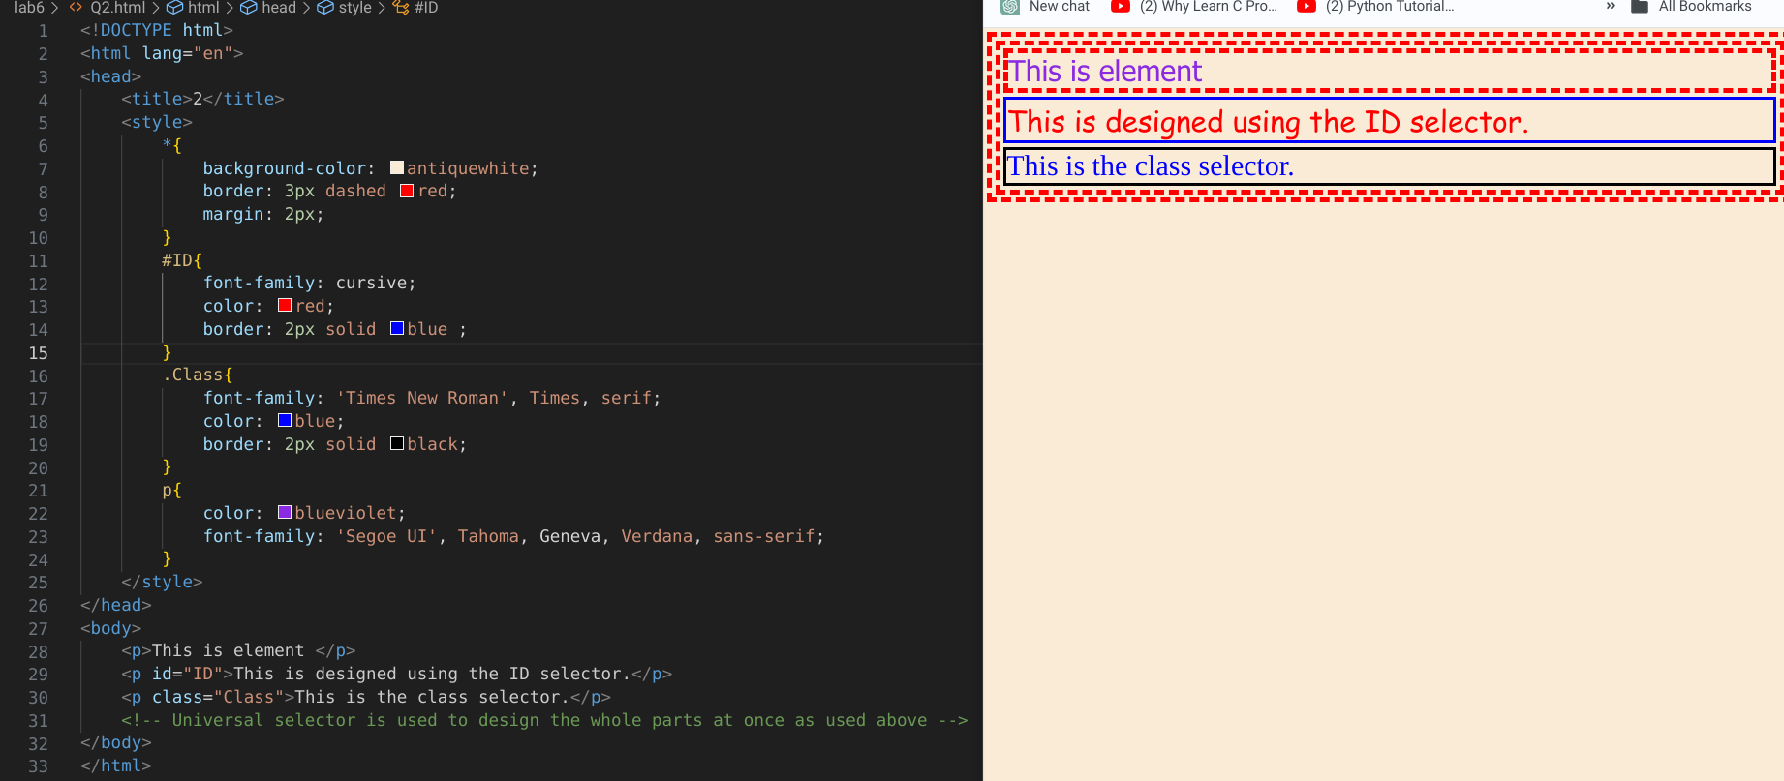

**Question 3): To create a web page that displays college information using various Style sheets. (You can use your idea)**

**Code:**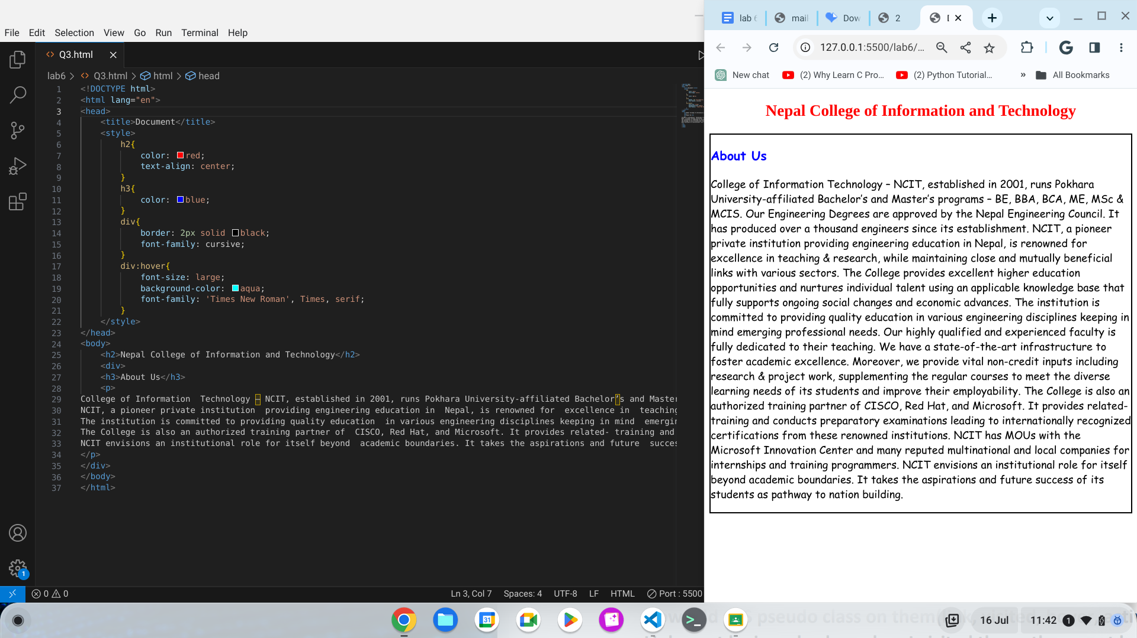



**Question 4): Create Hover.html in which include text “I live in Nepal” 6 times. Now add CSS pseudo class on them(link, visited, hover, activate). Link must be in red color, when I visited them, they must be on blue color and when I hover on them**

**a) Color changes to yellow**

**b) Font size changes to 150%**

**c) Background color changes to black**

**d) Font family changes to monospace**

**e) Text decoration hidden**

**f) Text decoration Wavy**

**Code:**

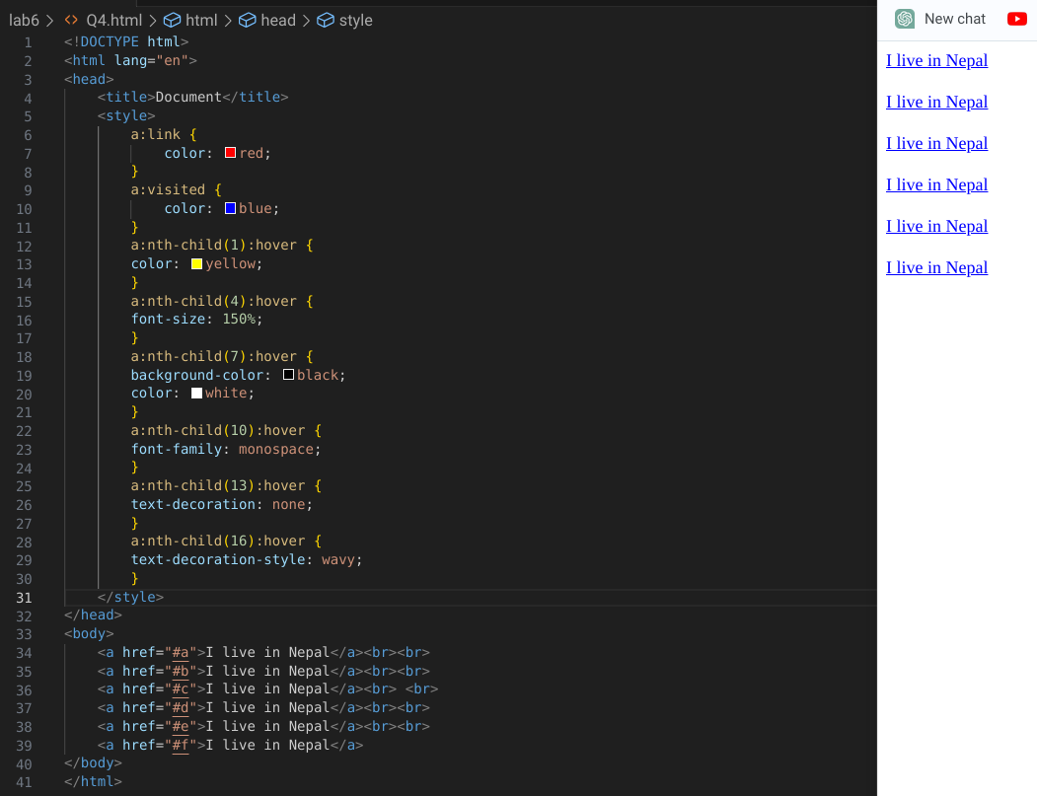

**Question 5): Use All pseudo elements on your Html code**

**Code:**

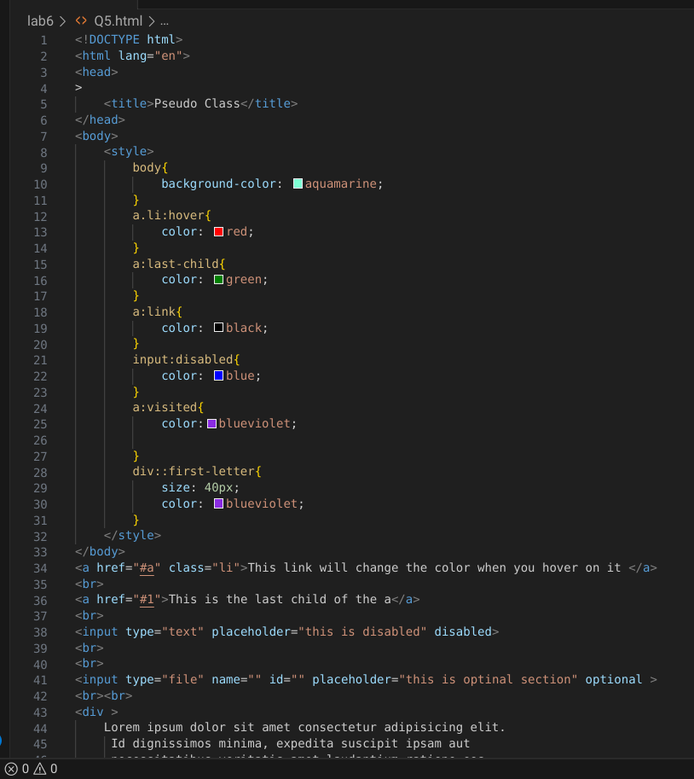

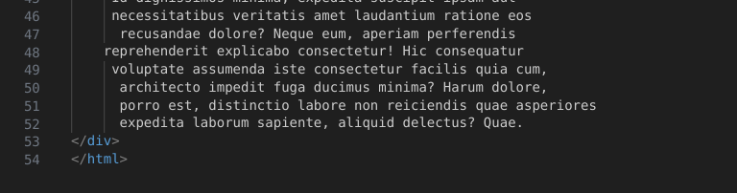

**Output:**

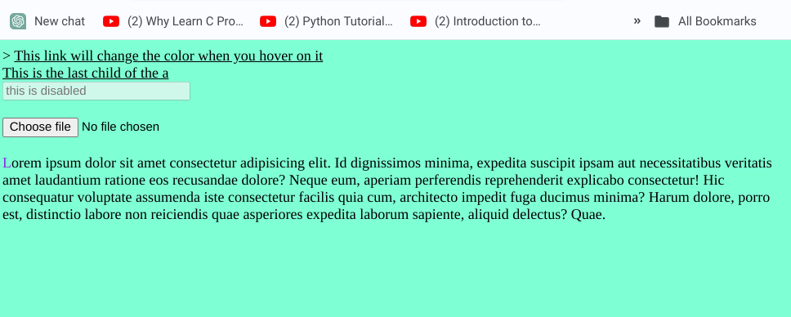

**Question 6): Use All kinds of Background and border properties on your Html document.**

**Code:**

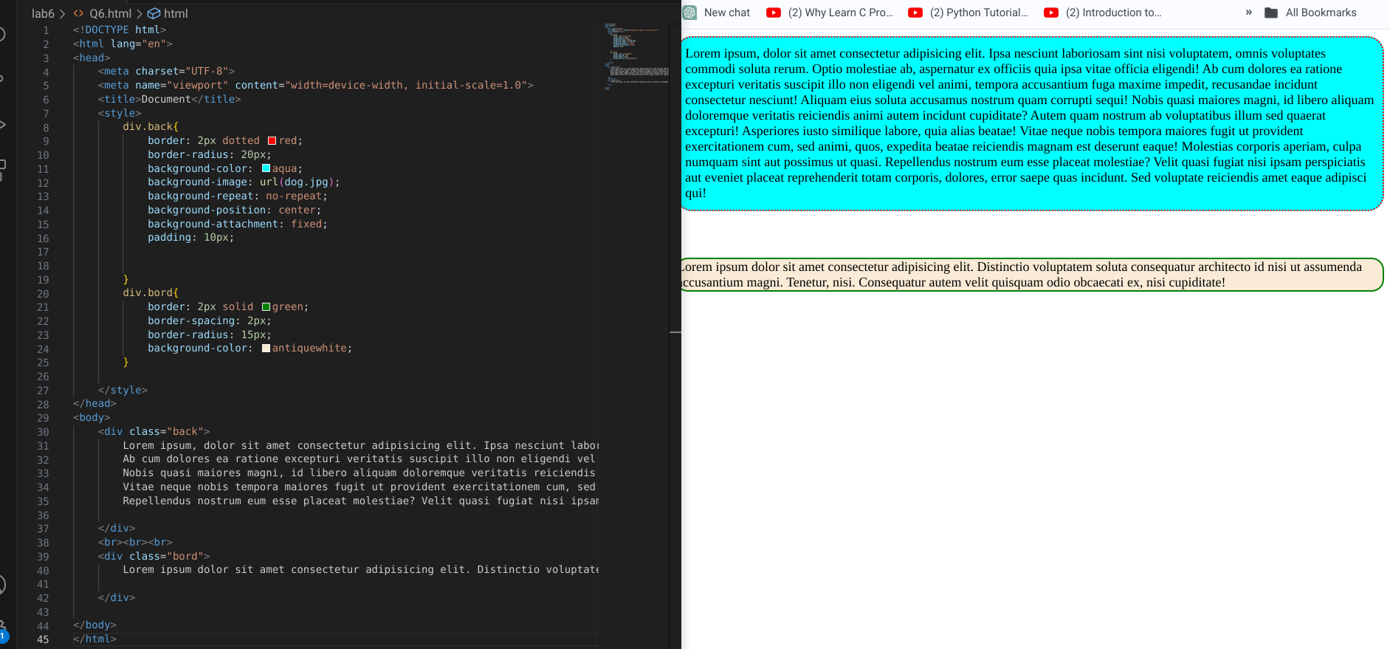

**Question 7): Use all kinds of Text properties of CSS on Your HTML document.**

**Code:**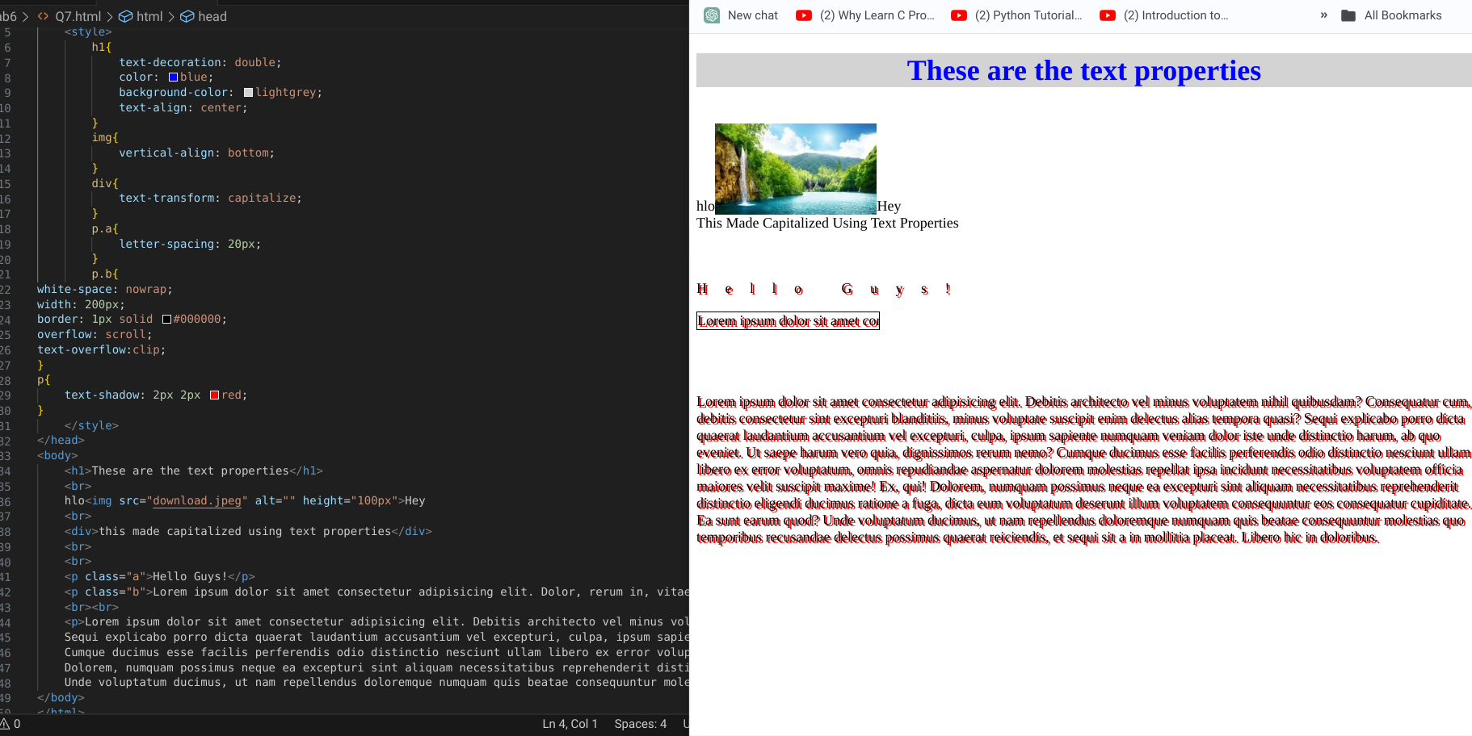

**Question 8): Use all kinds of List Properties of CSS on your HTML document.**

**Code:**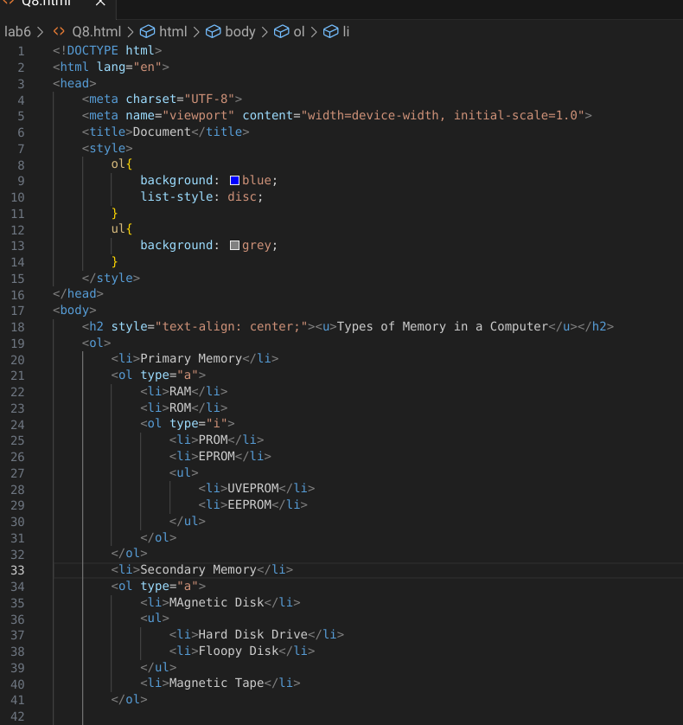

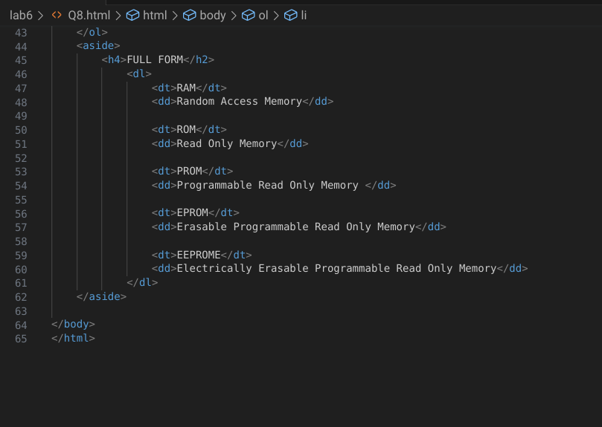

**Output:**

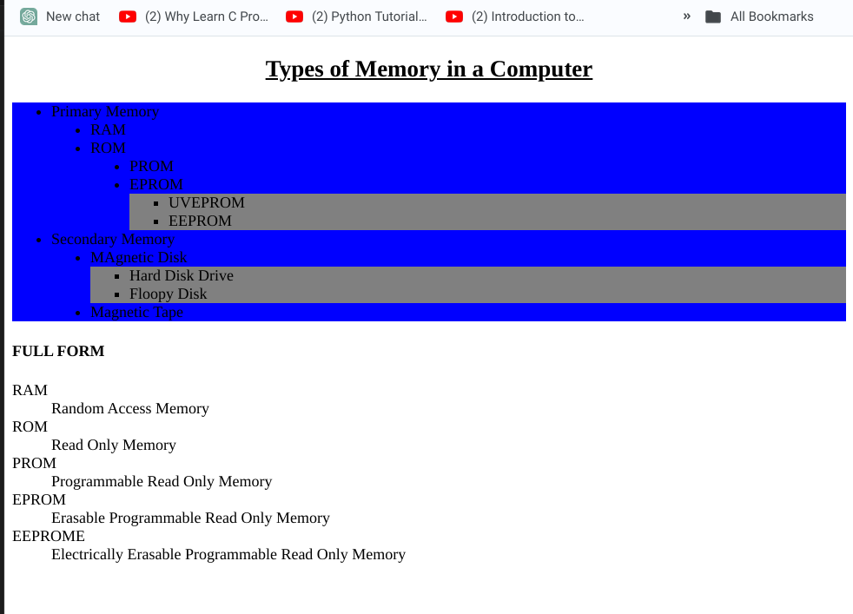

**Question 9): Make Stripped table with hoverable effect.**

**Code:**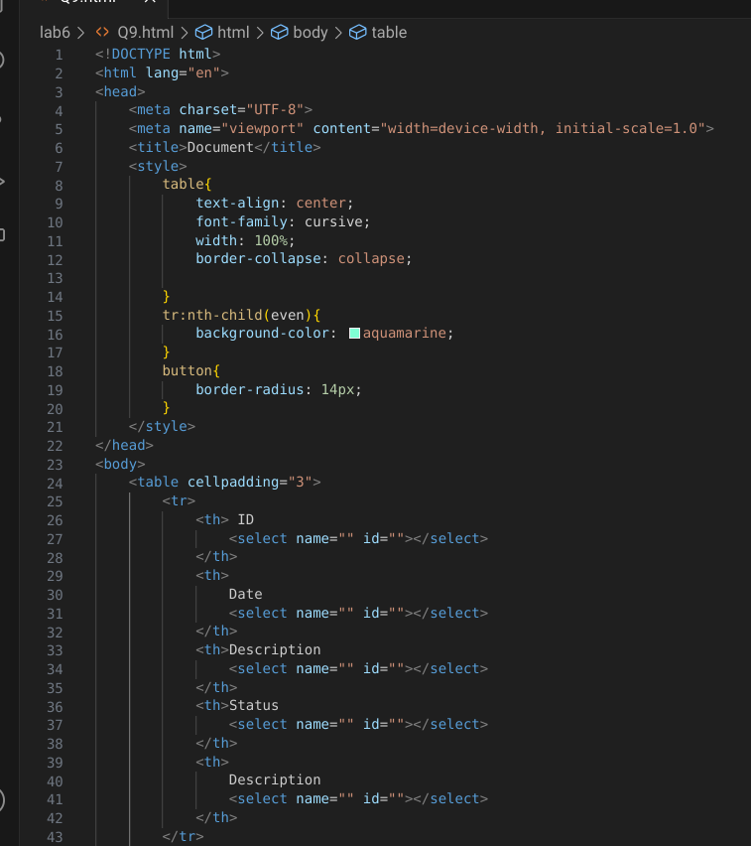

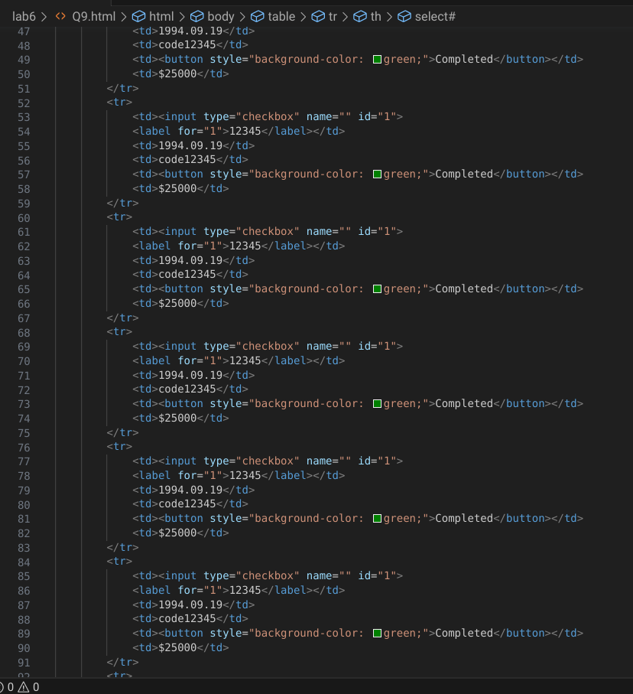

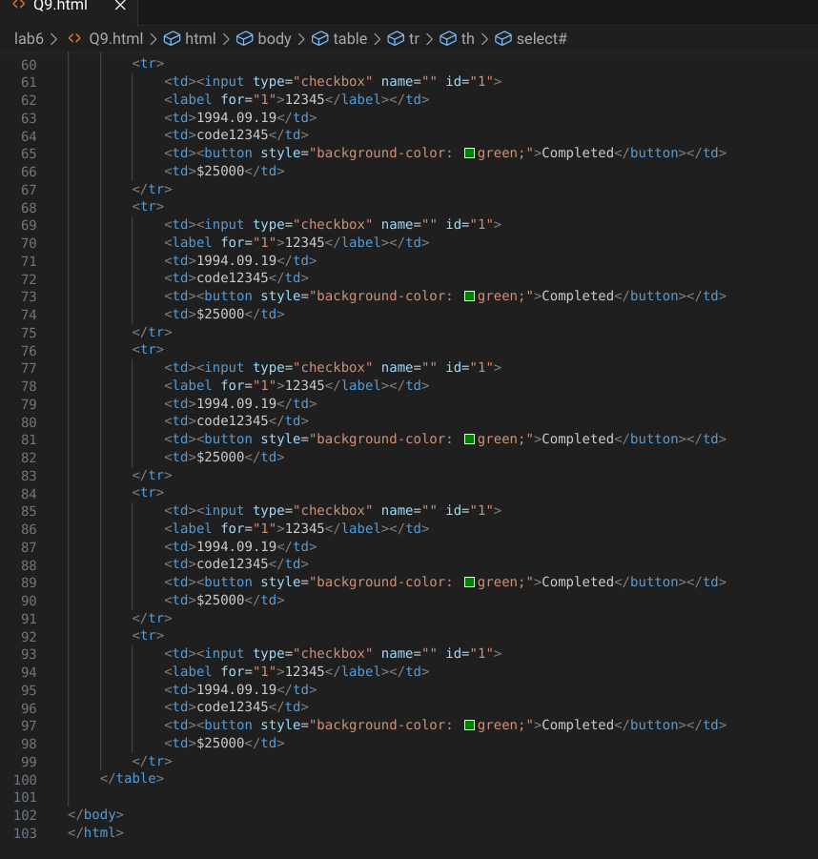

**Output:**

